Installation guide
This guide provides instructions for installing GitHub, Anaconda, & JupyterLab.

A - GitHub setup (5 minutes)
GitHub is an online platform for version control & collaboration built on top of Git (a free & open-source distributed version control system that tracks changes to files over time).
Why use GitHub?
- Version Control: Keeps a history of all changes to your files, allowing you to revert to earlier versions or view the changes made and who made them.
- Collaboration: Multiple people can work on the same project simultaneously without overwriting each other's work.
- Repositories (repos): Projects are stored in repos, which contain all the files, history, and documentation.

A.1 - Create a GitHub account
- To create a GitHub account, visit https://github.com/ and click on "Sign up":
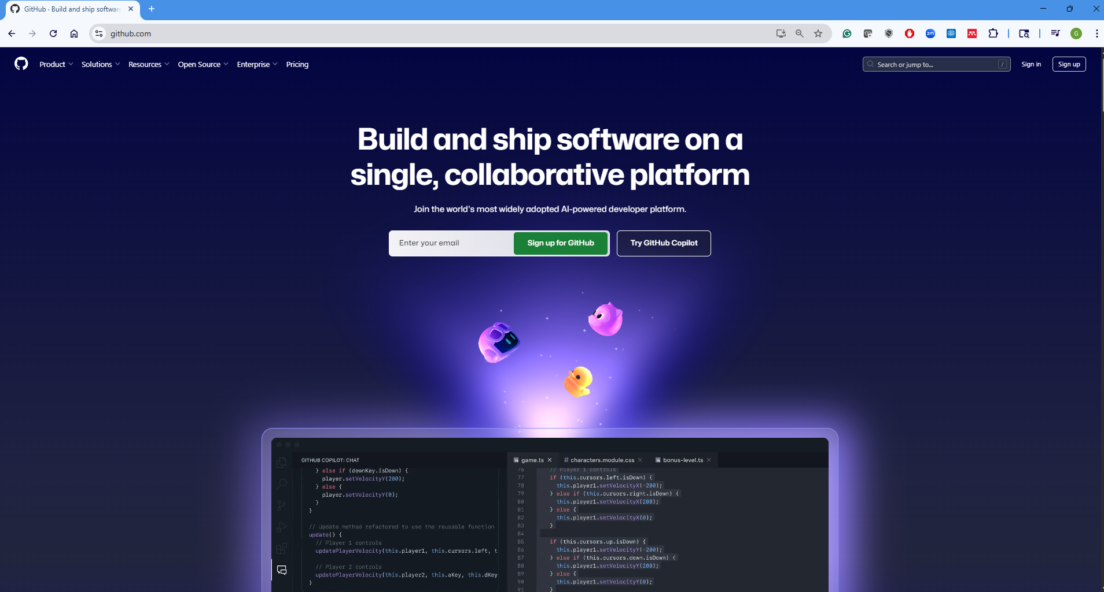
- Complete the registration form:
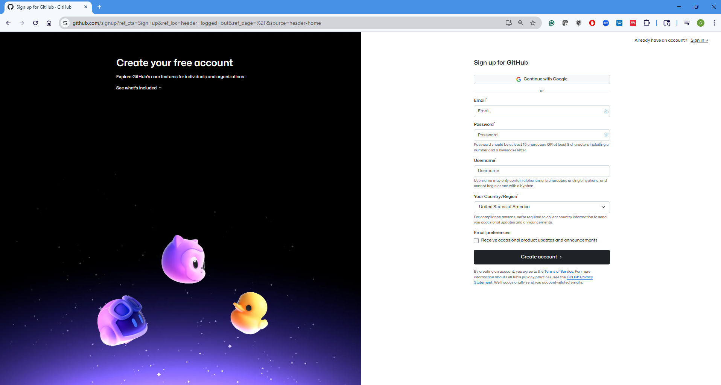

A.2 - Create final project repo (After your team number is assigned)
- Click on "Create Repository":
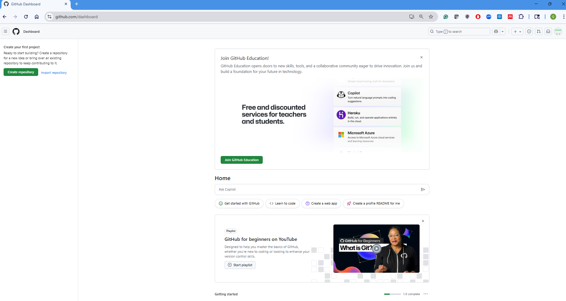
- Configure the repo: Each team must create only one repo and follow the repo name format; e.g., if your team number is 0, your team repo name must be CAI_4105_2026_Fall_Team_0.
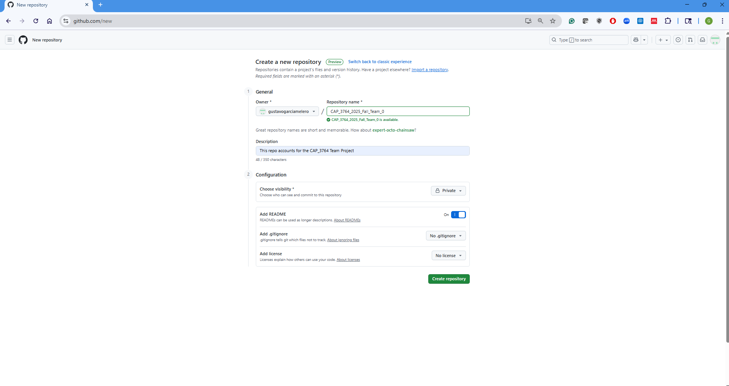
- Add me as a collaborator: Go to settings → Collaborators → Add people → ggarciam@fiu.edu
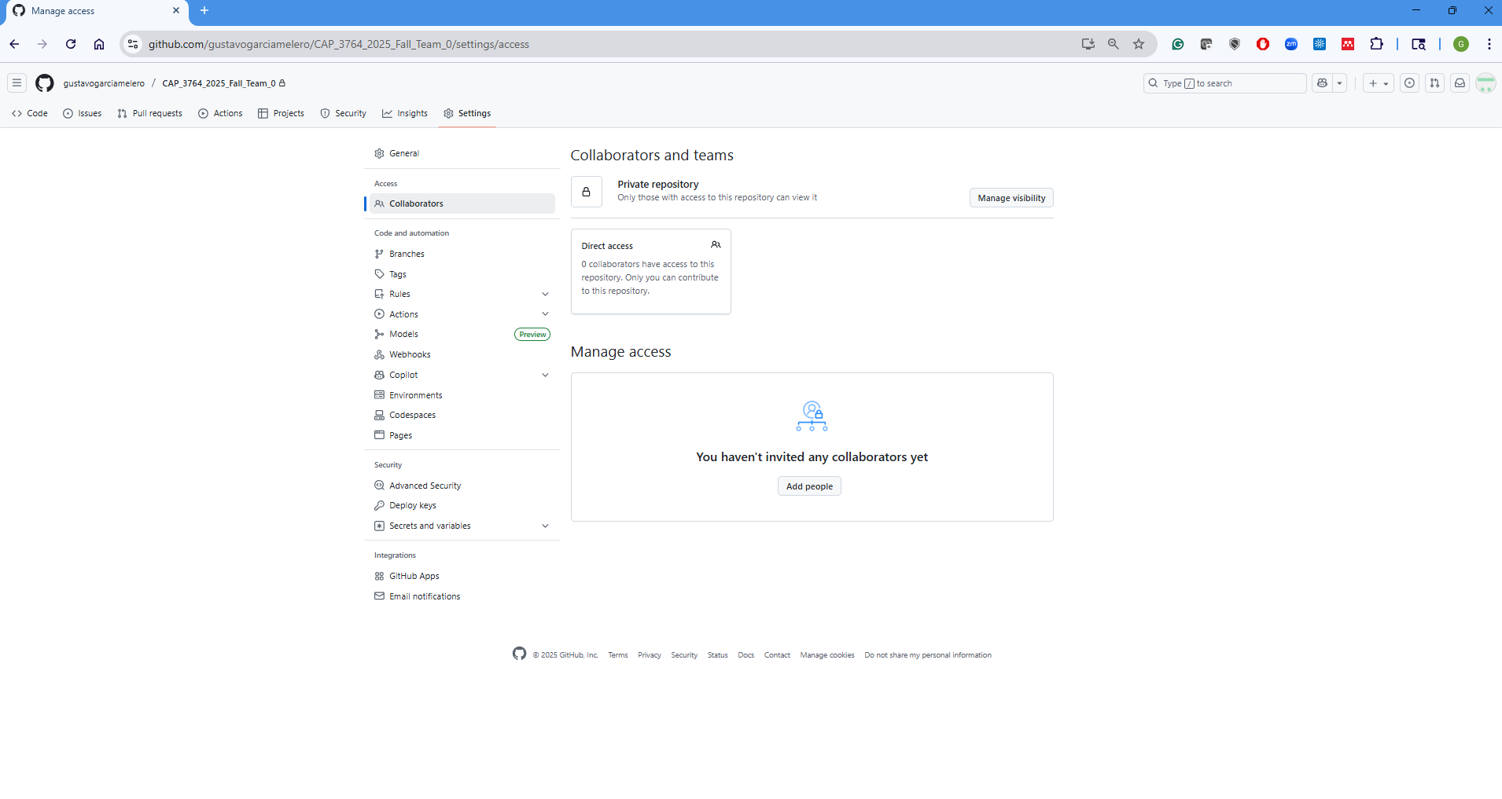

B - Anaconda installation (10-20 minutes)
Anaconda is a free and open-source distribution of Python & R, specifically designed for data science & machine learning.

B.1 - Key features of Anaconda:
- Package Management
Anaconda includes Conda, a powerful package manager that simplifies:
  - Installing, updating, and removing packages.
  - Managing multiple environments with different Python versions and dependencies.
- Pre-installed Libraries
Comes with 250+ popular data science libraries out-of-the-box, including: NumPy, Pandas, Matplotlib, Scikit-learn, TensorFlow, Jupyter, etc.
- Environment Management
You can create isolated conda environments to manage project-specific dependencies and avoid package conflicts.
- JupyterLab
Anaconda includes JupyterLab, a popular tool for writing and running Python code interactively, especially in data science.
- Anaconda Navigator
A graphical user interface (GUI) to launch applications (JupyterLab, Spyder, etc.), manage environments, & install packages without using the command line.
In summary, Anaconda is an all-in-one toolkit for data scientists, analysts, and developers to efficiently work with Python for data science, machine learning, & numerical computing.

B.2 - Download Anaconda
https://www.anaconda.com/download#download-section
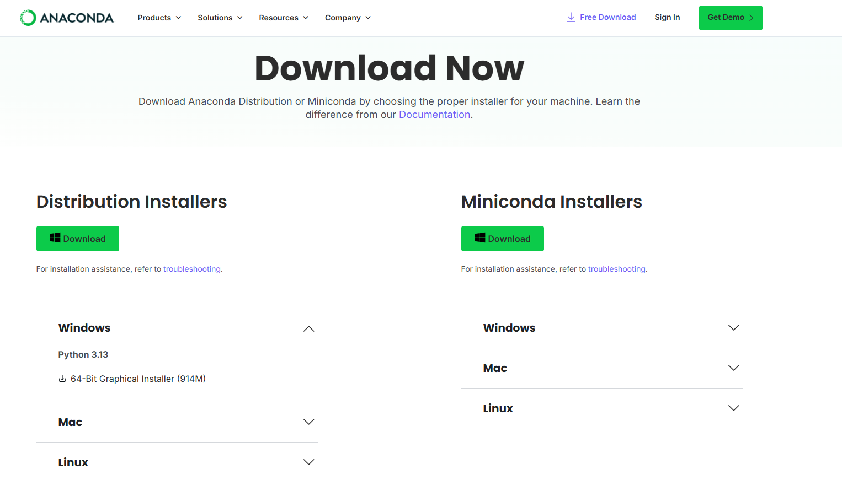

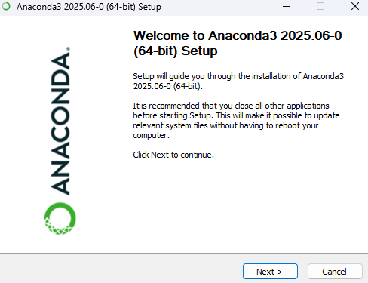


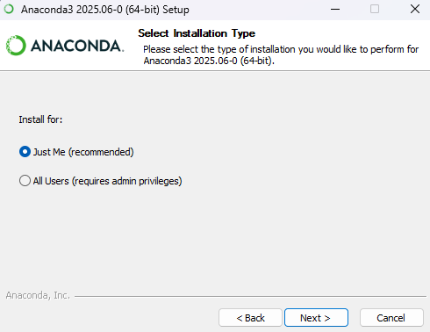

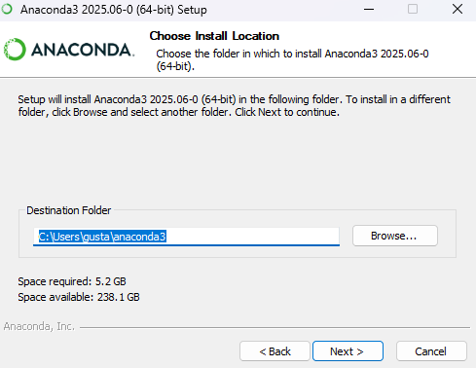

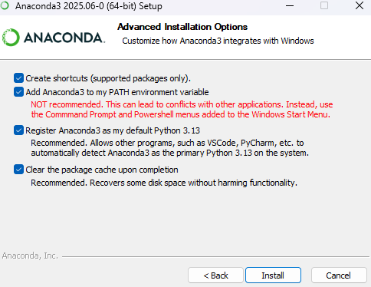
* It is safe to enable "Add Anaconda3 to my PATH environment variable" if you know how Windows PATH works.
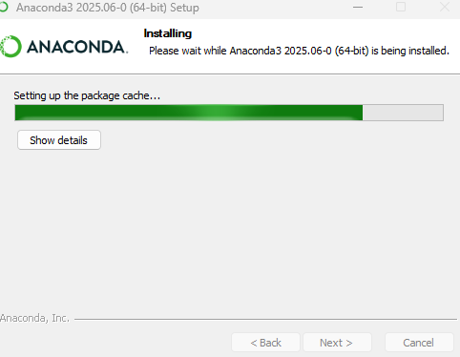

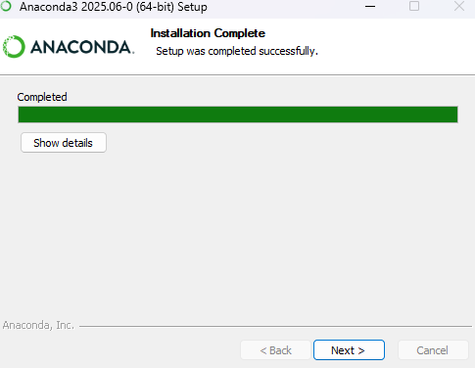

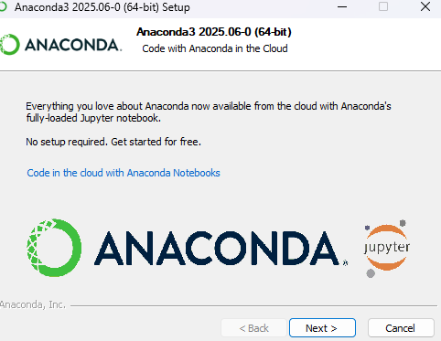

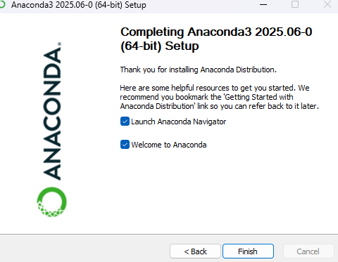

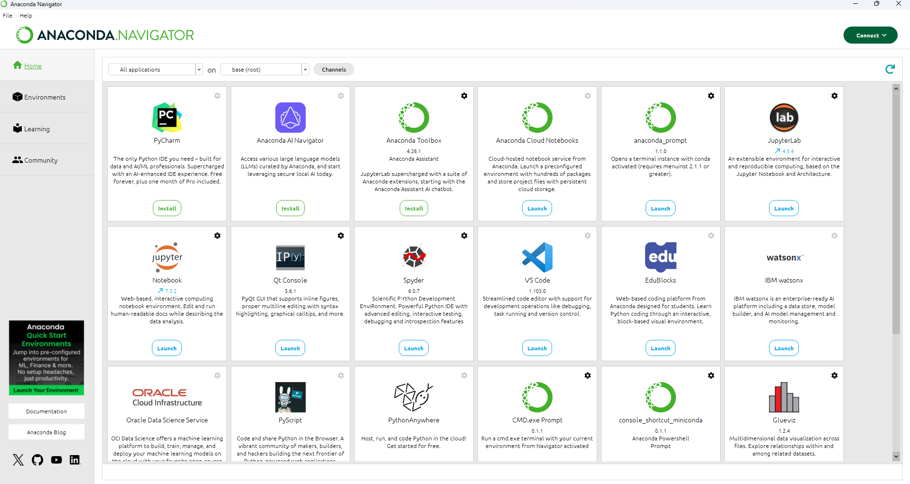

We have two options to launch JupyterLab:
- Using Anaconda Navigator (it usually takes longer to start).
- Pin JupyterLab to the taskbar for quicker access, following these steps:
- Create a Shortcut:
- Right-click on the desktop → New → Shortcut
- In the location field, type cmd /k jupyter lab
- Click Next, name it something like JupyterLab, then click Finish.
- Customization:
- Set an icon: Right-click on the new shortcut → Properties → Change icon → Browse (C:\your_path\anaconda3\Menu)
- Specify the default starting folder: Right-click on the new shortcut → Properties → Start in → Add the path to your starting folder
- Pin to taskbar:
- Right-click the shortcut → Pin to Taskbar
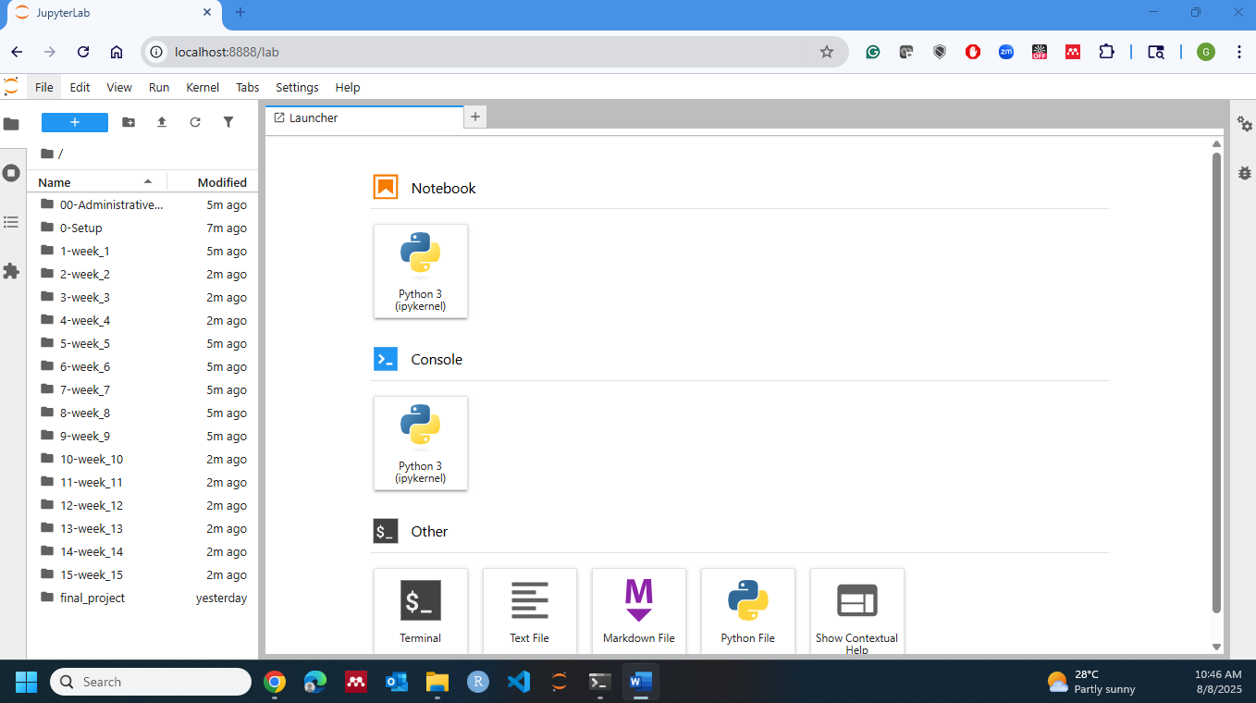
*If you want to change the theme → Settings → Theme → JupyterLab Dark

C - GitHub & JupyterLab (5 minutes)
*If you do not have a GitHub account, go to A - GitHub Setup (first section in this guide).
- Make sure Git is installed in your environment: Go to JupyterLab and open a new terminal → Type " git --version"
*If the command returns an error, download and install Git from https://git-scm.com/downloads before continuing.
*If Git is already installed, continue to the next step.
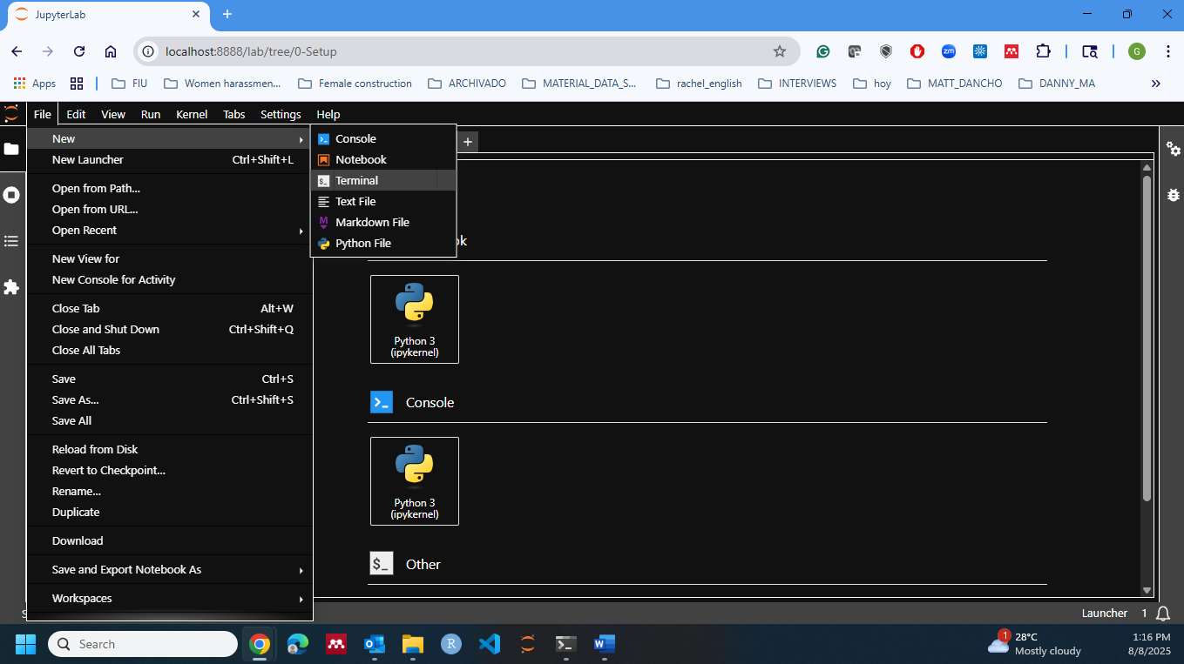
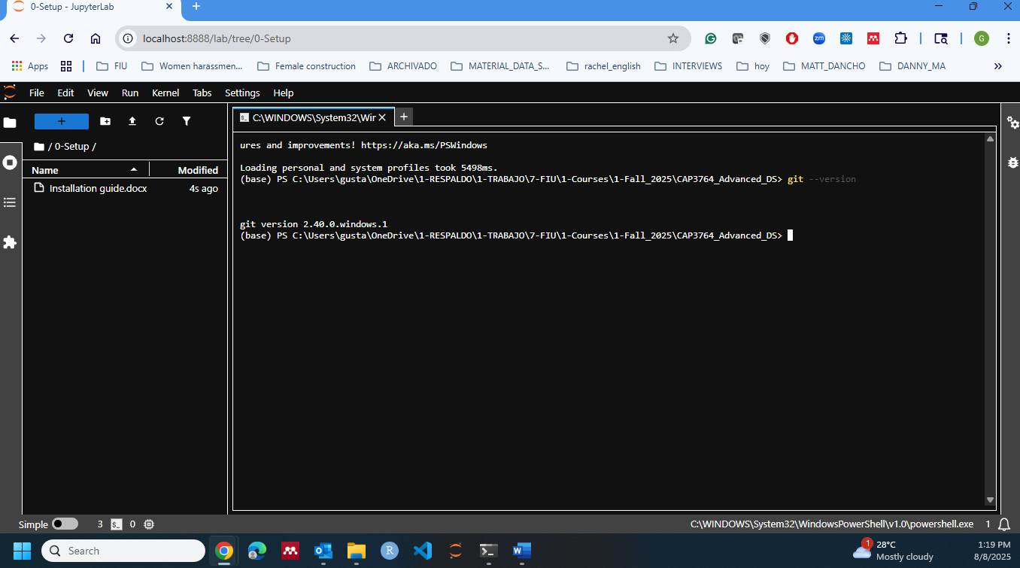

- Enable Git extension in Jupyter Lab (optional but helpful), type in terminal (one at a time):
pip install jupyterlab-git
jupyter server extension enable --py jupyterlab_git
*If the Git icon already appears in the left sidebar, you may skip this step.
- Shut down and restart JupyterLab (Git icon should be on the left sidebar):
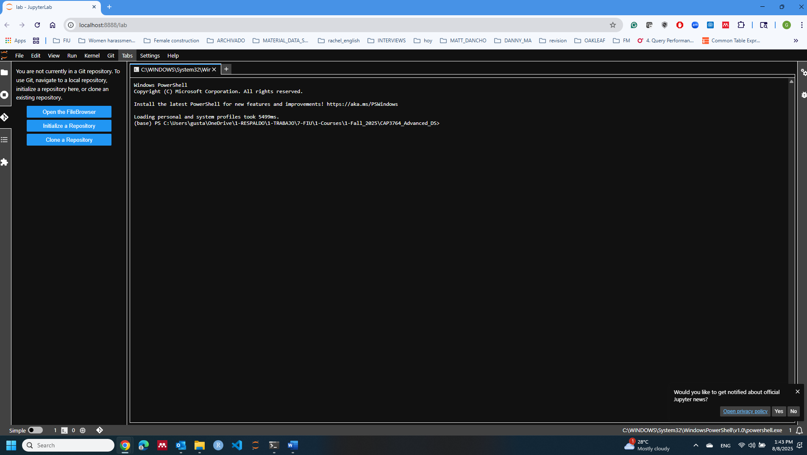
- Create a Personal Access Token (PAT): Open GitHub in a web browser → Click on your profile picture → Settings → Developer Settings (left sidebar) → Personal access tokens → Fine-grained tokens → Generate new token → Only select repositories (Select your team repo).
*You can also create a token for all your repos.
*GitHub no longer accepts account passwords for Git operations. A Personal Access Token (PAT) is used for authentication instead.
- Open a terminal in Jupyter Lab and copy (Only the first time using GitHub):
git config --global user.name Your_GitHub_Username
git config --global user.email your_email@example.com
git config --global credential.helper manager-core
*Use the same username and email address associated with your GitHub account.
*This stores your GitHub credentials securely in Windows so you will not have to enter your Personal Access Token every time you push changes.
- Select the location where you want to clone (download a local copy of) your repo:
cd "Your location" (e.g., C:\Your_Path\repo)
- Clone your GitHub repo, type in the terminal:
git clone https://github.com/Your_GitHub_Username/your-repo-name.git
Now you can open and edit notebooks in the cloned repo and use the GitHub extension to commit, push, and pull.

D – Verify your installation (2 minutes)
- Open a notebook and execute:
import sys
import pandas as pd
import numpy as np
import sklearn

print(sys.version)
print(pd.__version__)
print(np.__version__)
print(sklearn.__version__)
- Open a terminal and execute:
git --version
conda --version
If these commands run successfully, your installation is complete. Congratulations!

